# INTRODUCTION

# Overview

A human resources(HR) assistant is a professional who is responsible for daily administrative and HR duties of an organisation.

# Purpose

Maintains accurate and up-to-date human resources files, records and documentation.It is also responsible for managing and handling the day to day HR activities.

# Problem Definition & Design Thinking

# Empathy Map

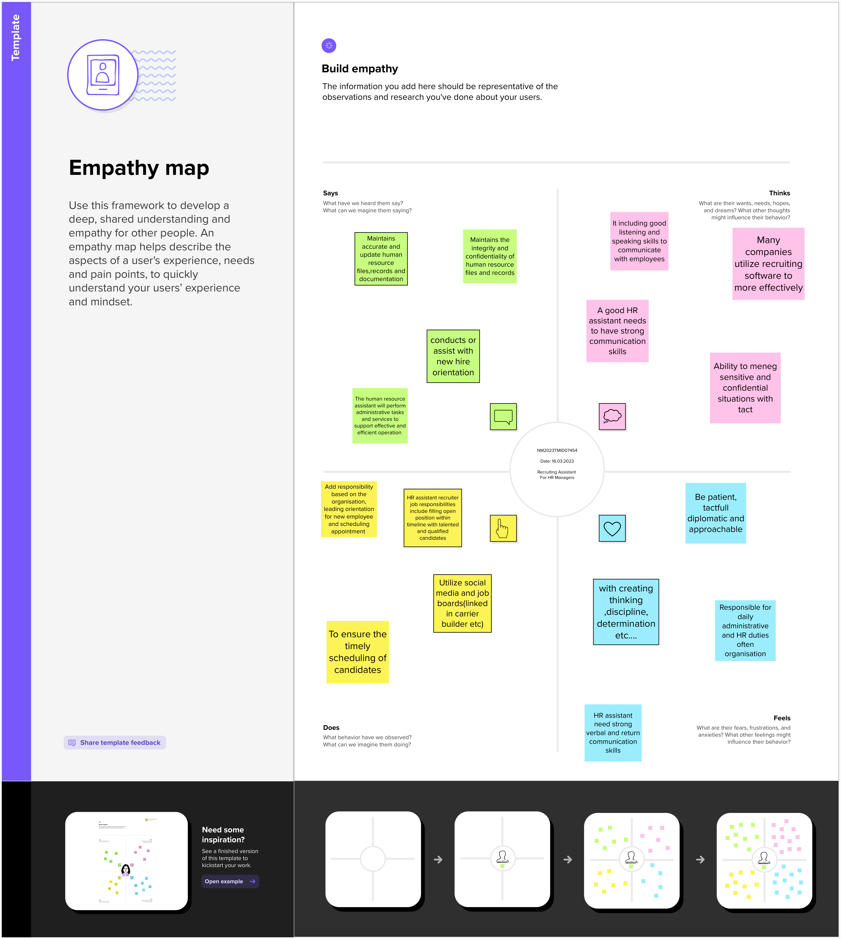

# Ideation & Brainstorming Map

# RESULT

# Data Model:

|  |  |
| --- | --- |
| **Object name** | **Fields in the Object** |
| Job posting site | |  |  | | --- | --- | | Field label | Data type | | Status | Text | | Technical site | Text | | Description | Text | |
| Job posting | |  |  | | --- | --- | | Field label | Data type | | Portion | Master- detail relationship | | Job posting site | Master-detail relationship | |

# Activity & Screenshot

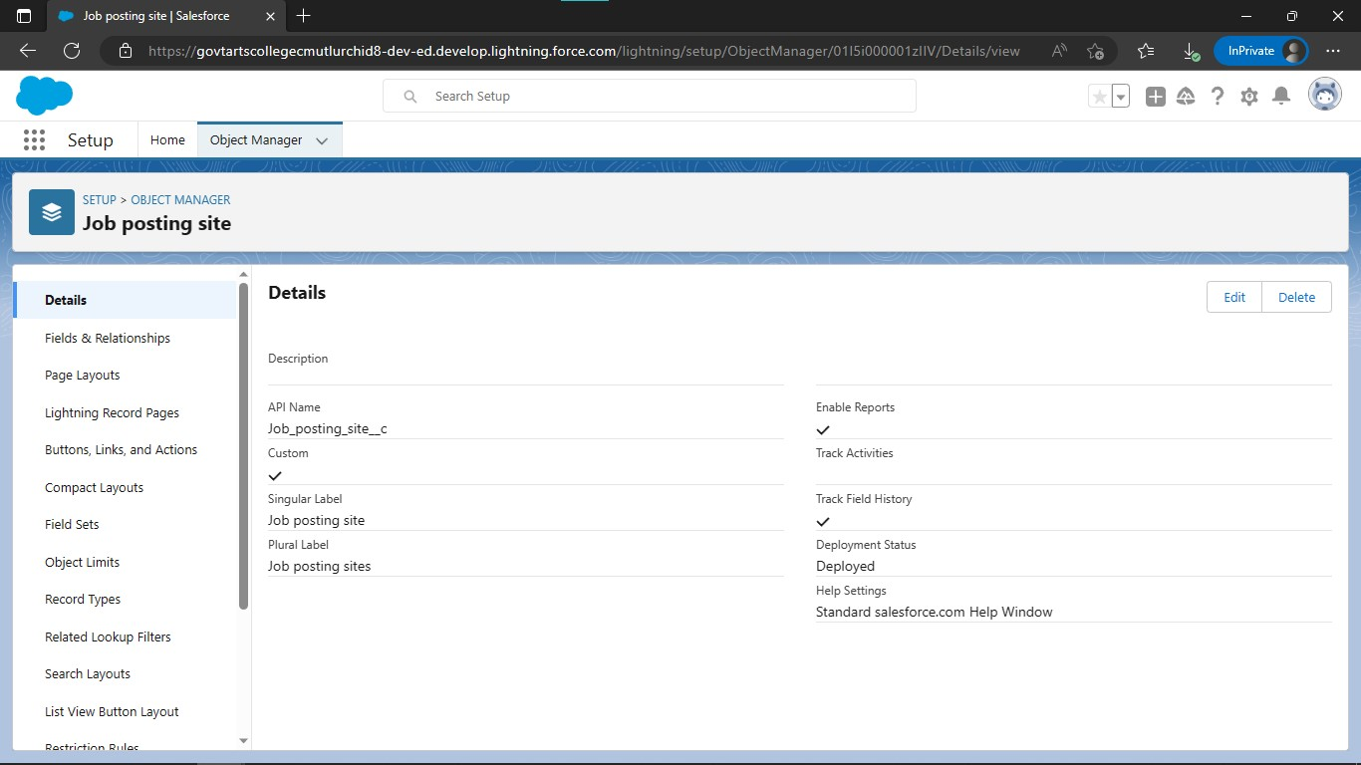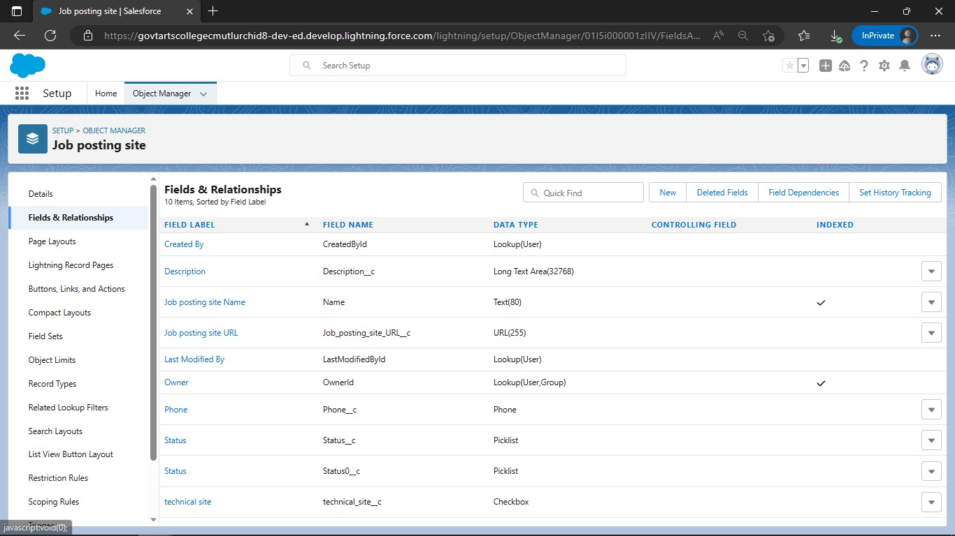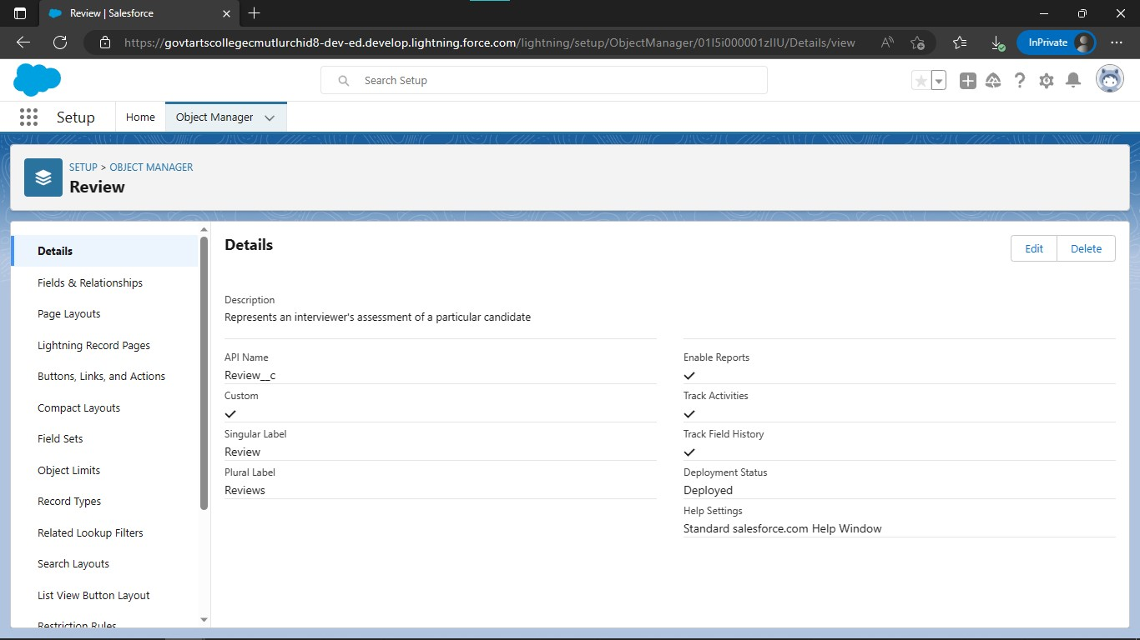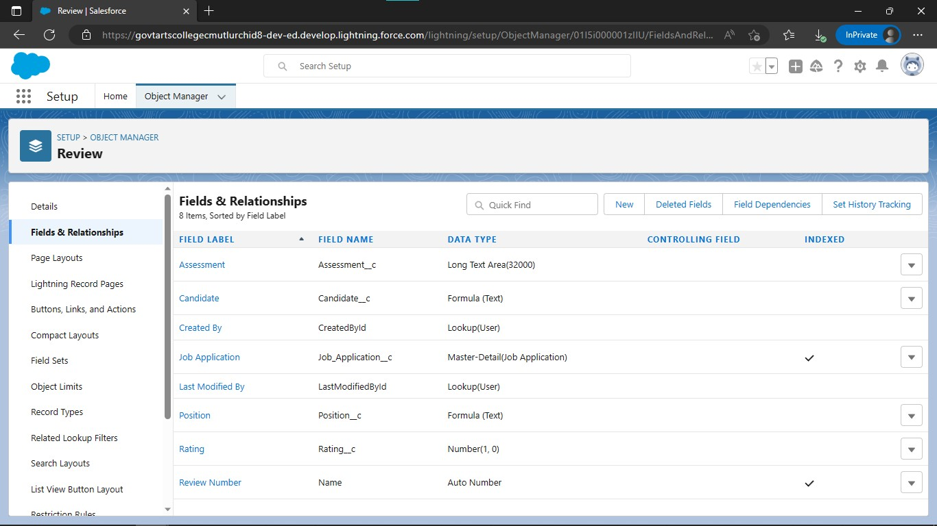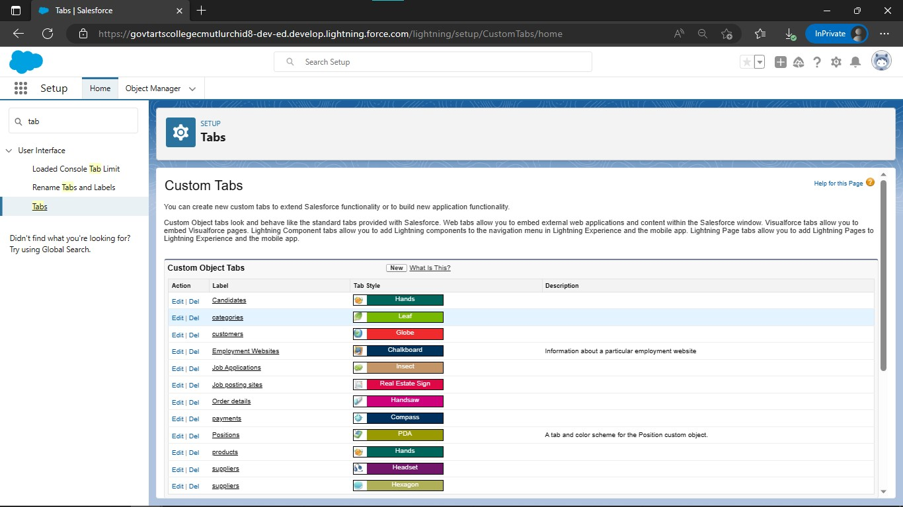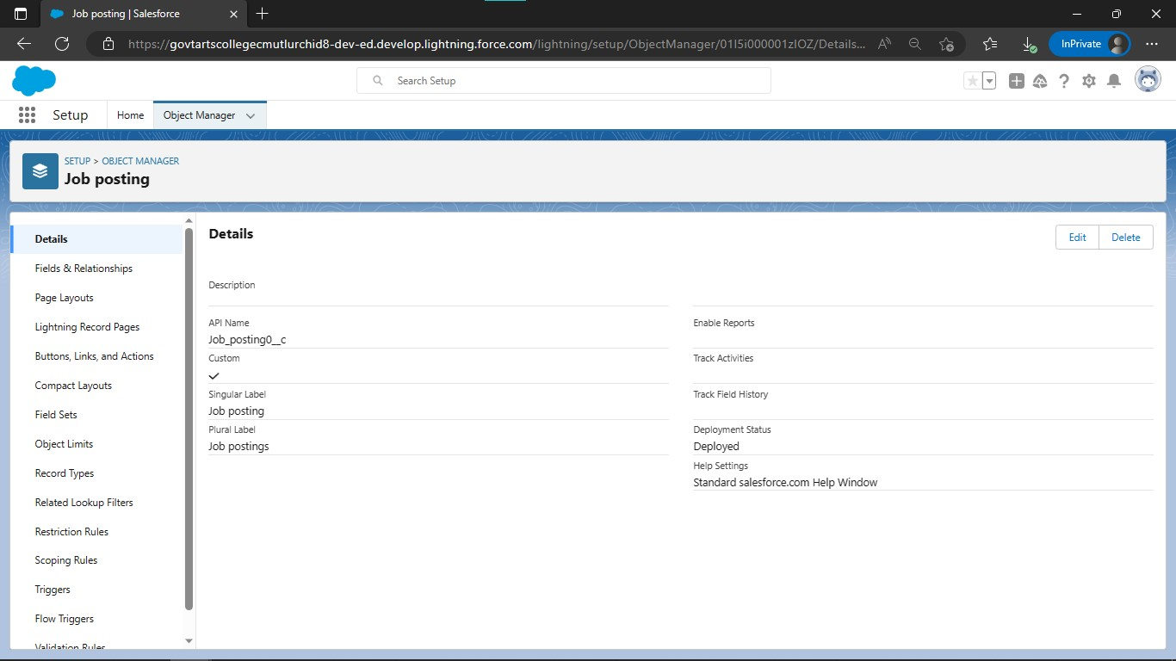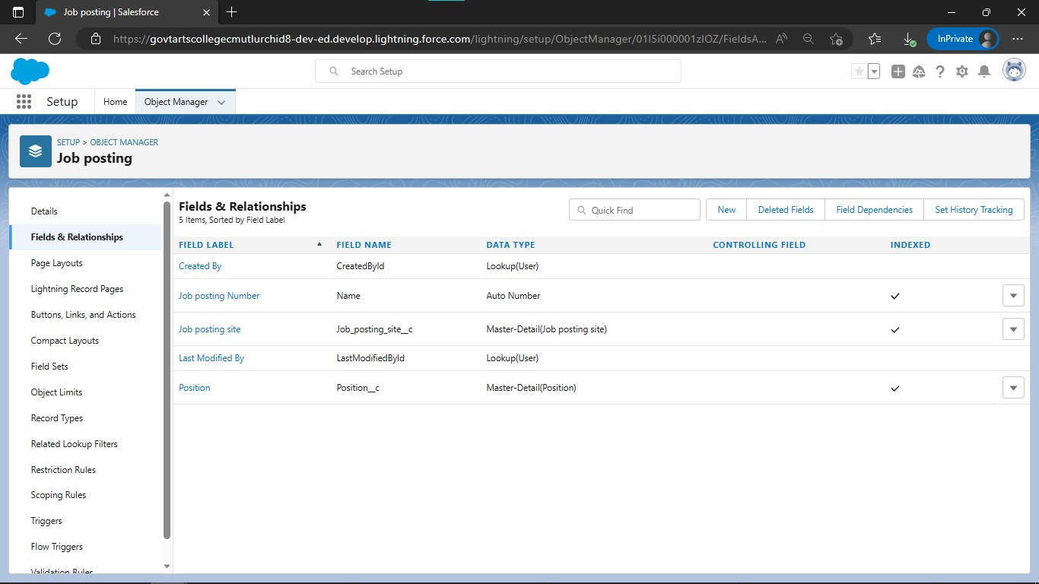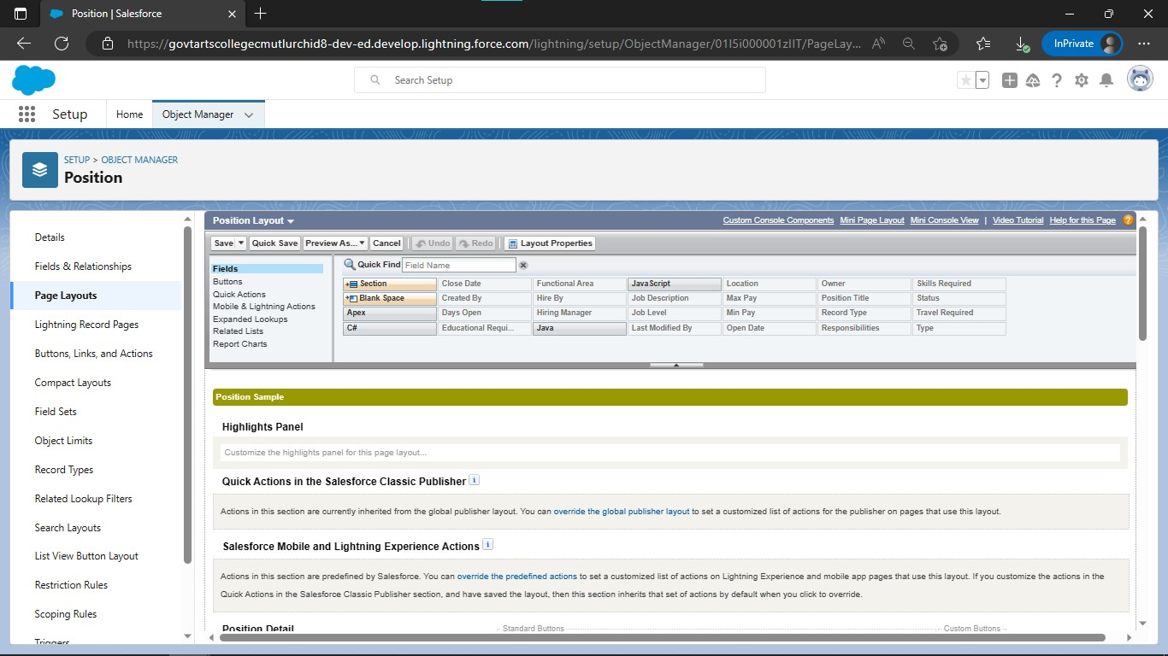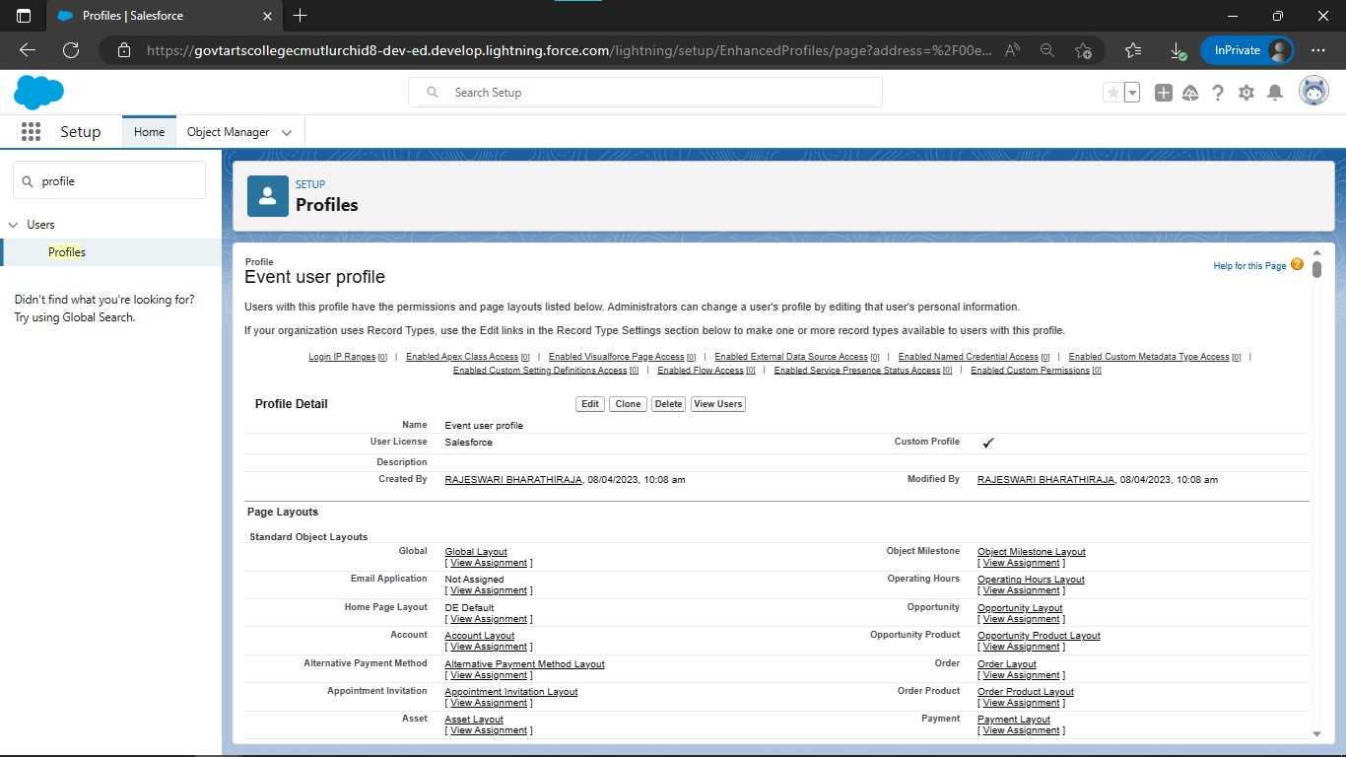

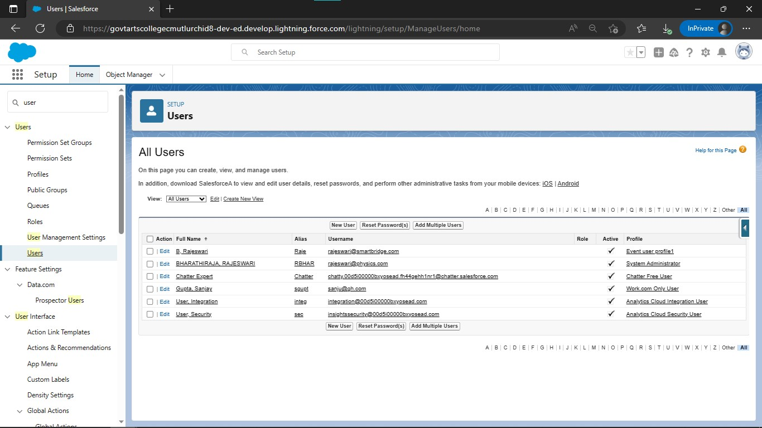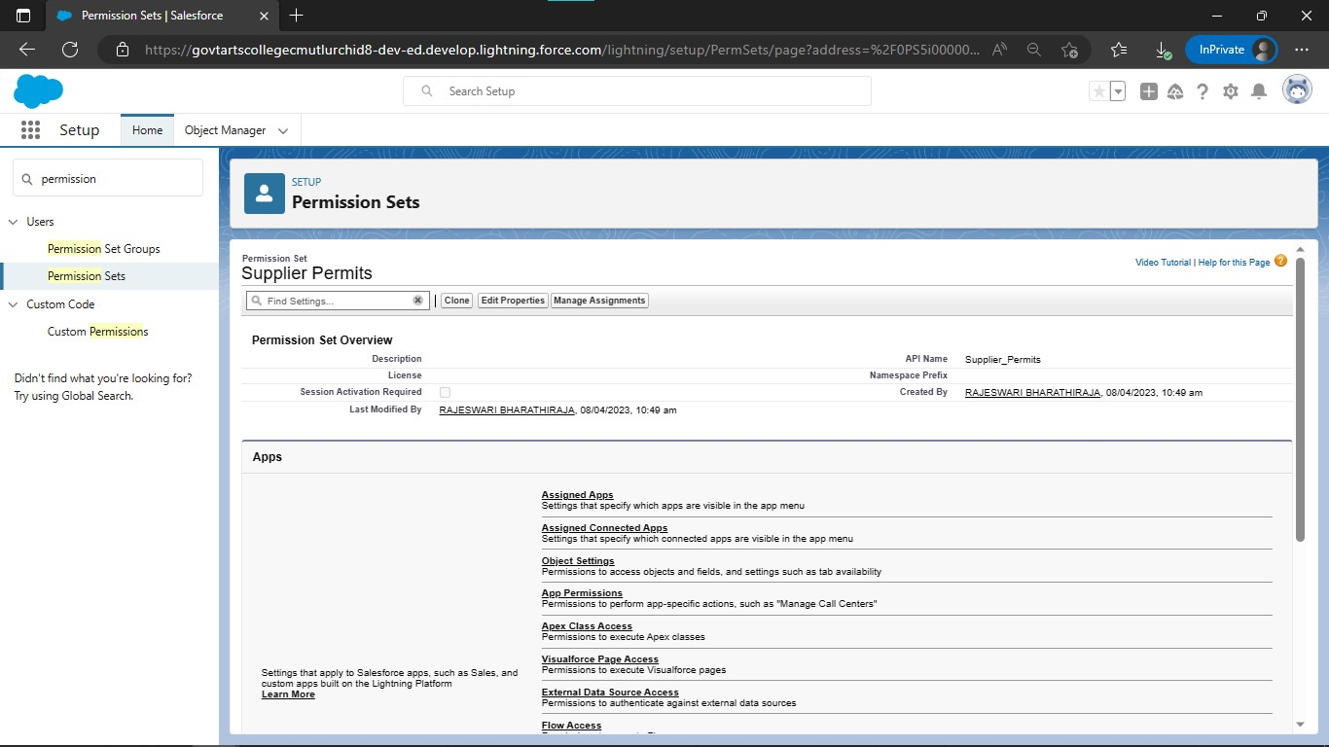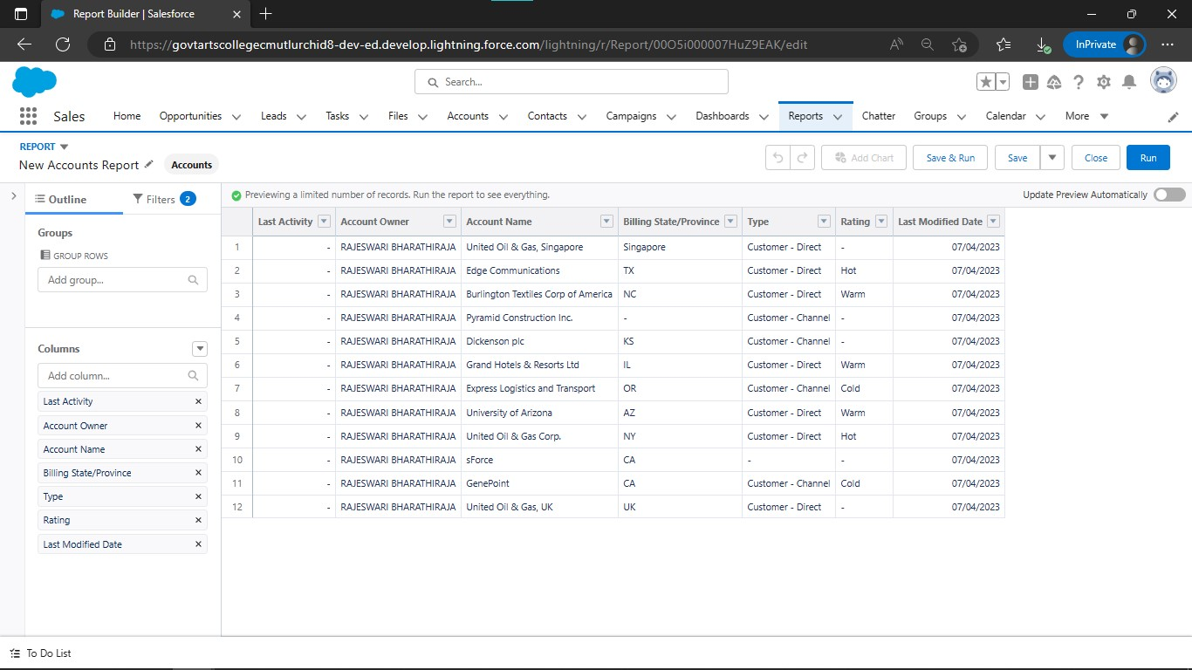

# Trailhead Profile Public URL

Team Lead -https://trailblazer.me/id/rbharathiraja

Team Member 1 -https://trailblazer.me/id/ppanner1

Team Member 2 –https://trailblazer.me/id/praba2003

Team Member 3 –https://trailblazer.me/id/rkumarapathi

# ADVANTAGES & DISADVANTAGE.

# ADVANTAGES:

* Hiring internal candidates can be more efficient than recruiting externally.
* They are prescreened for culture fit.
* Their track record is easily accessible.
* They may not always need full interviews with managers.
* May be familiar with people in their new team especially in smaller businesses.

**DISADVANTAGES:**

* Employees who were considered for a role could feel resentful or external candidates is eventually hired.
* Leave a gap in your existing workforce, if when you promote someone to fill an open position, their old position becomes vacant.
* Ensure promotions or job moves aren't the only ways to recognise employees or help them adavance their careers.
* Avoid communicating an opening if you already have a candidate in mind.

# APPLICATIONS

* Main responsibilities of a recruiting assistant are implementing HR functions, providing clerical support, performing background checks, monitoring staff activity, organising interviews and helping with payroll preparation.
* Recruiting Assistant provide support to hiring managers and help them find suitable candidates for a vacant position.

# CONCLUSION

In conclusion, the particle of HRM needs to be integrated with the overall strategy to ensure effective use of people and provide better returns to the organizations in terms of ROI(Return On Investment) or every dollar or rupee spent on them.

# FUTURE SCOPE

One should remember that HR needs to adapt i.e an HR professional must not stop learning. HR will not be replaced, but HR take up relevant courses to empower your working and be in a race.